
BOSTON
INTERNATIONAL COLLEGE
END TERM EXAM
Level: Bachelor |  | Year : 2022
Program: BCIS Sem: II |  | Full Marks : 100
Course: Object Oriented Programming (Java) |  | Time : 3 hrs

Candidates are required to give their answers in their own words as far as practicable. The figures in the margin indicate full marks.

Group A
Very Short Answer Questions
Attempt all the questions. Give your answer in few lines: 10*2=20
- Differentiate instance and static variable.
- What is use of super keyword in java? List any 3 uses.
- What is the difference of using isAlive() and stop() method ?
- What is finally used for?
- What is purpose of SimpleDateFormat class in java?
- Why was Swing developed even though AWT was enough for GUI programming in java?
- Prove why java is architecturally neutral language?
- Define deadlock scenario.
- Write a program to generate random integer value upto 10.
- What do you mean by Auto-boxing and Auto-unboxing?

Group B
Descriptive Answer Questions
Attempt any six questions. 6*10=60
- What are different Exception in java? Write a program to create a Custom Exception.
- What is HashMap and HashSet? Write a program to show the differences
- Why final and abstract cannot be used at a time? Write a program to show inheritance in interface.
- What is event delegation model in java? What are the terminologies used in event handling? Write a program to demonstrate an event handling when a button is pressed consider the necessary criteria yourself.

  - What are Collections? Explain the uses of Array List with an example.
  - Write a program that takes two strings from user and check whether they are identical or not.

  - What is wrapper class? Explain wrapper classes available in java.
  - What is multithreading? Explain the life cycle of thread.

Group C
Case Analysis
- XYZ School approaches to develop desktop based application software of Student Management System. The “Registration System” looks like below:

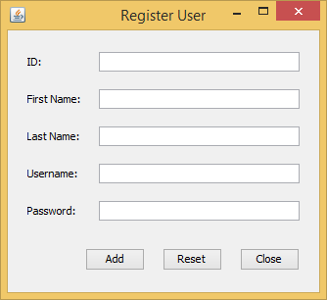
- You are required to design the GUI same as in above figure of Register User GUI. 5
- In “Register User” screen, when user click on "Add" button, then all the supplied information is received and displayed to user in the console. 15

